1. Create a user named Thanos via adduser command

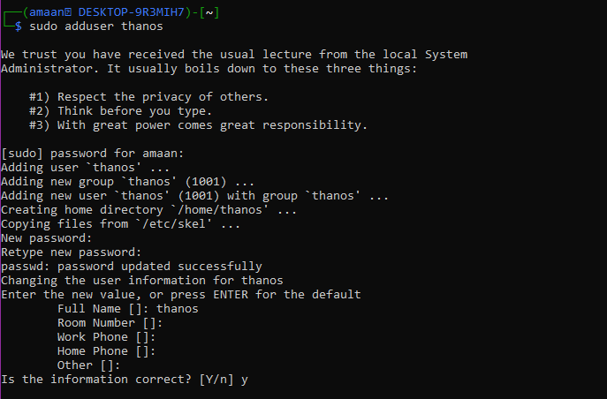

2) Create a group named Gauntlet and add Thanos to this group

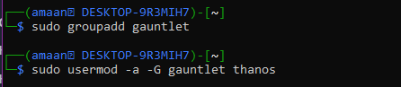



3) Allow the group to execute all the commands similar to sudo group by configuring the /etc/sudoers file.



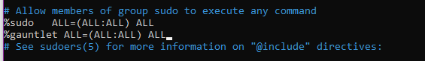

Now thanos can perform all operations.

4) Create a new user called Ironman and allow him to execute the useradd command by configuring the /etc/sudoers file.

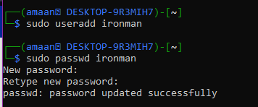





5) Ironman will create other avengers namely, Cap, Thor, Hulk, Widow and Hawkeye.

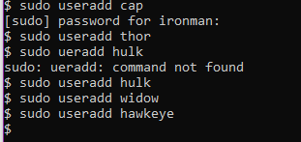

With useradd, these users will have a default password and they can change it when they first login using passwd command.

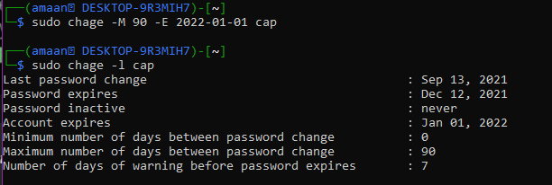

Do this for every avenger.

Now, edit the /etc/passwd file using vipw command like this

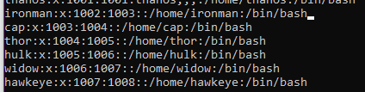

To set default shells as bash for avengers.

Now we have completed all requirements for the avengers.

6) Thanos snapped his fingers and killed half of the universe. Widow and hawkeye were dead. Login to thanos and delete Widow and hawkeye via userdel.

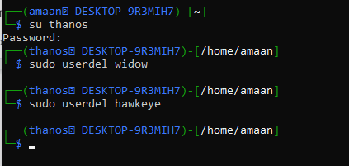

7) Avengers fight back and finally Iron man has the gauntlet and he snapped and defeated Thanos as per following steps: a) Switch to root and add Iron man to Gauntlet group. b) Login to Iron man account and delete Thanos account. c) As Thanos is dead now, Iron man destroyed the infinity gauntlet by deleting the Gauntlet group

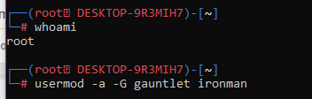

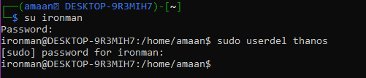

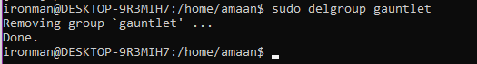

Everything is done. The avengers won. Yayyyyyy :)